ELEG 309 - Example Problems Chapter 6-2

**Example 6.4**

Consider the circuit shown in Fig 6.22(a), which is redrawn in Fig 6.22(b) to remind the reader of the convention employed throughout this book for indicating connections to dc sources. We wish to analyze this circuit to determine all the node voltages and branch currents. We will assume that ** is specified to be 100.

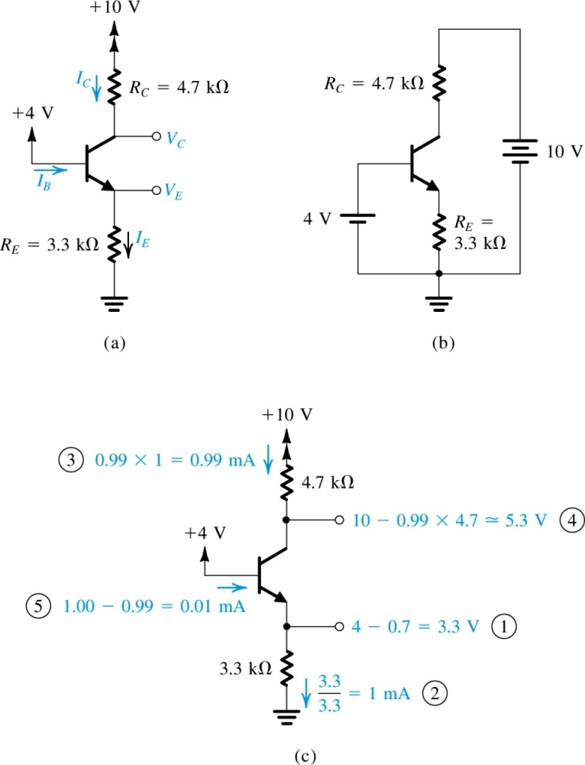

**Example 6.5**

We wish to analyze the circuit of Fig. 6.23(a) to determine the voltages at all nodes and the currents through all branches. Note that this circuit is identical to that of Fig 6.22 except that the voltage at the base is now +6V. Assume that the transistor ** is specified to be at least 50.

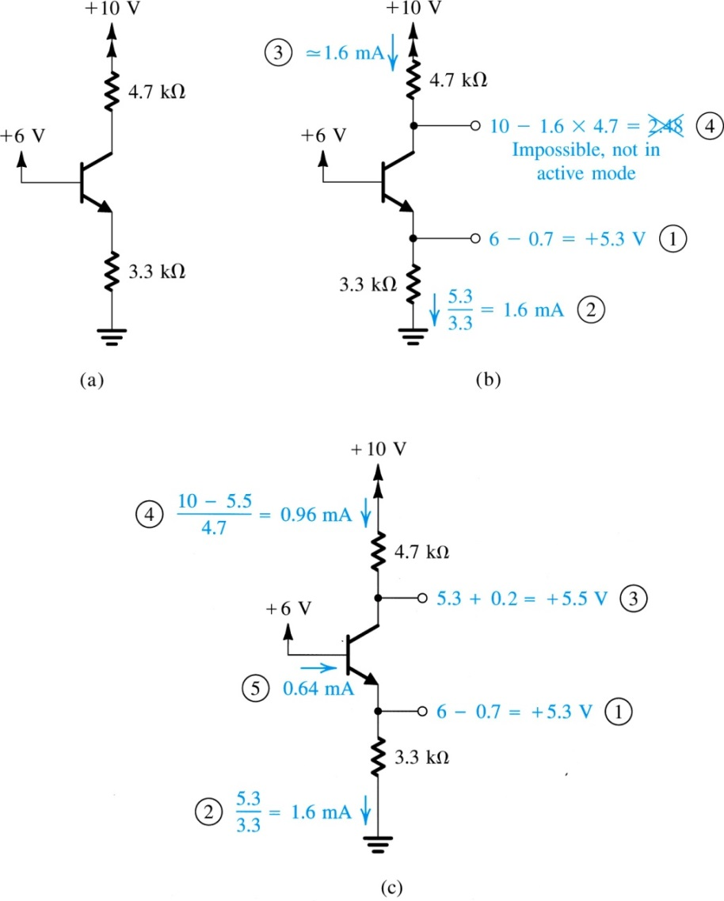

**Example 6.6**

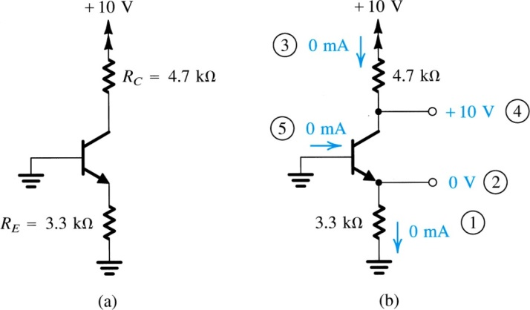We wish to analyze the circuit of Fig. 6.24(a) to determine the voltages at all nodes and the currents through all branches. Note that this circuit is identical to that considered in Examples 6.4 and 6.5 except that now the base voltage is zero.

**Example 6.7**

We want to analyze the circuit of Fig. 6.25(a) to determine the voltages at all nodes and the currents through all branches.

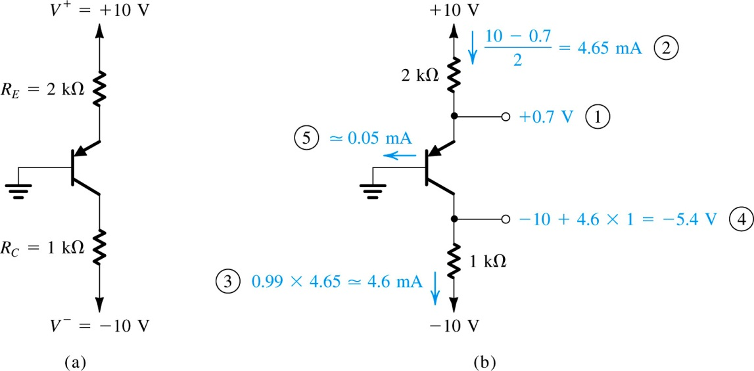

**Example 6.8**

We want to analyze the circuit in Fig. 6.26(a) to determine the voltages at all nodes and the currents in all branches. Assume ** = 100.

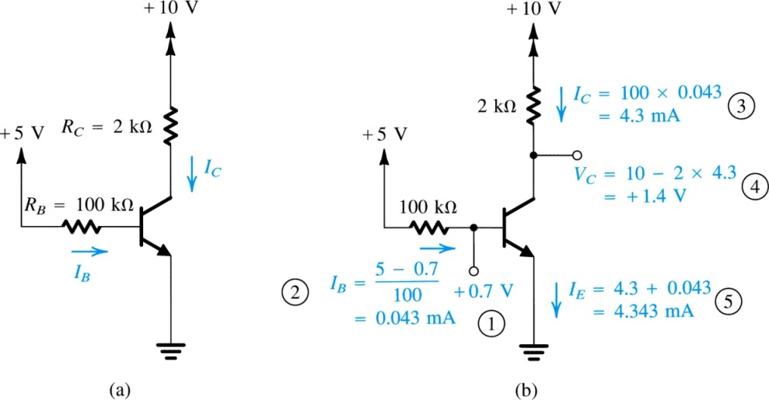

**Example 6.9**

We want to analyze the circuit in Fig.6.27 to determine the voltages at all nodes and the currents through all branches. The minimum value of ** is specified to be 30.

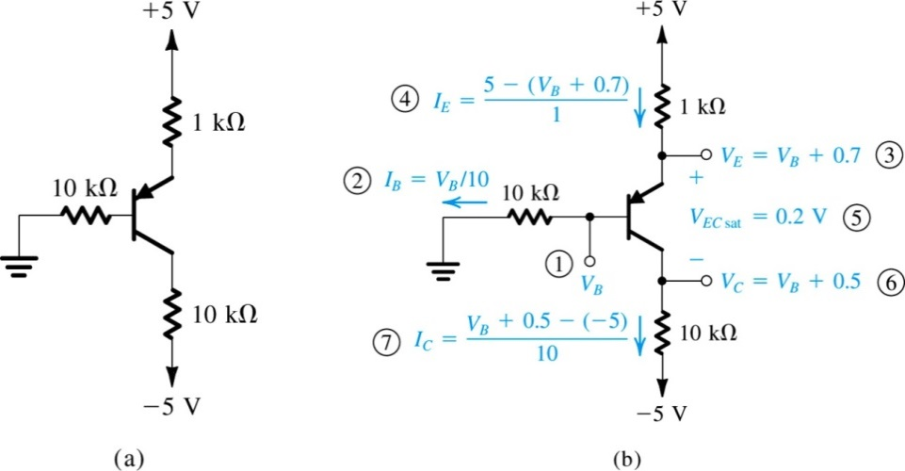

**Example 6.10**

We want to analyze the circuit in Fig. 6.28 to determine the voltages at all nodes and the currents through all branches. Assume ** = 100.

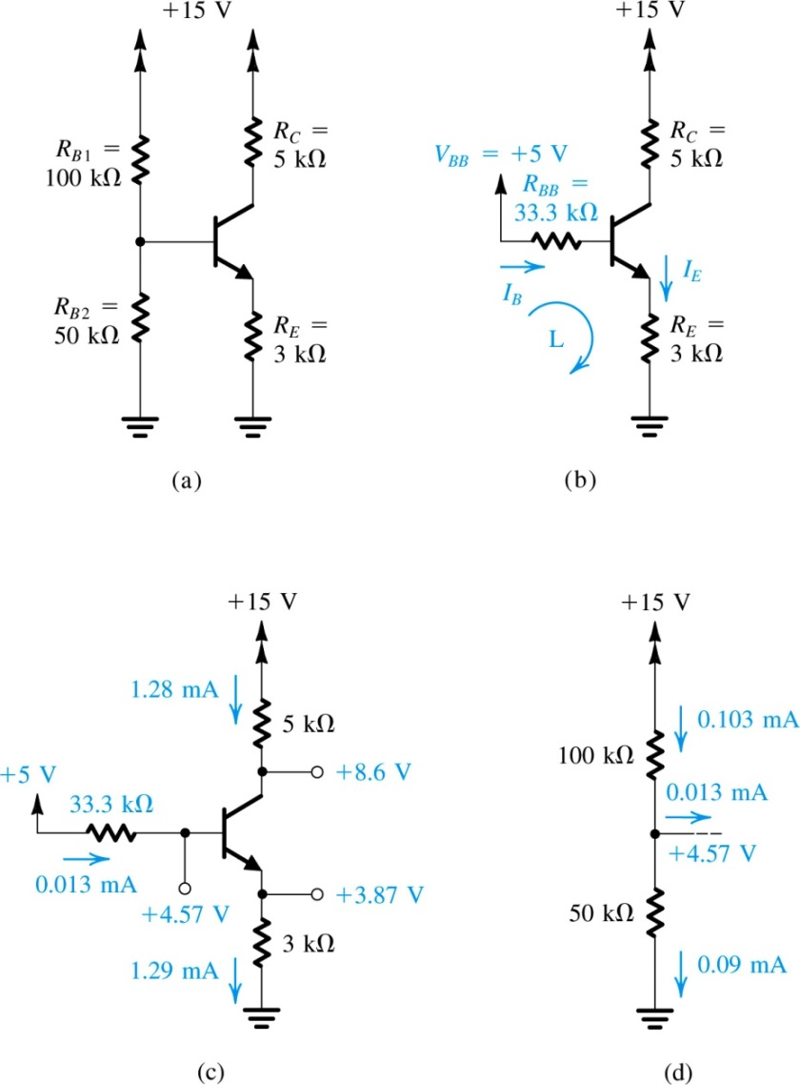

**Example 6.11**

We want to analyze the circuit in Fig. 6.29(a) to determine the voltages at all nodes and the currents through all branches.

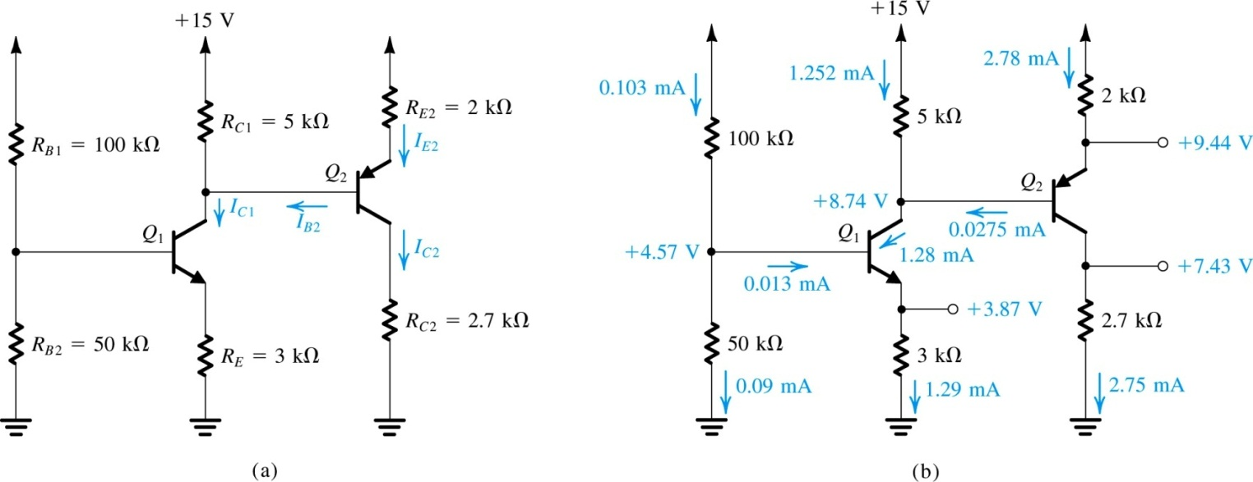

**Exercise 6.30**

The circuit in Fig. E6.30 is to be connected to the circuit in Fig. 6.30(a) as indicated; specifically, the base of *Q*3 is to be connected to the collector of *Q*2*.* If *Q*3has *b* = 100, find the new value of *VC*2and the values of *VE*3 and *IC*3.

